SCM ASSINGNMENT

HOW TO OPEN AND CLOSE A PULL REQUEST

OPENING A PULL REQUEST

* Open your repository on GitHub .
* Click on then it will show weather it is able to merge with/without conflicts.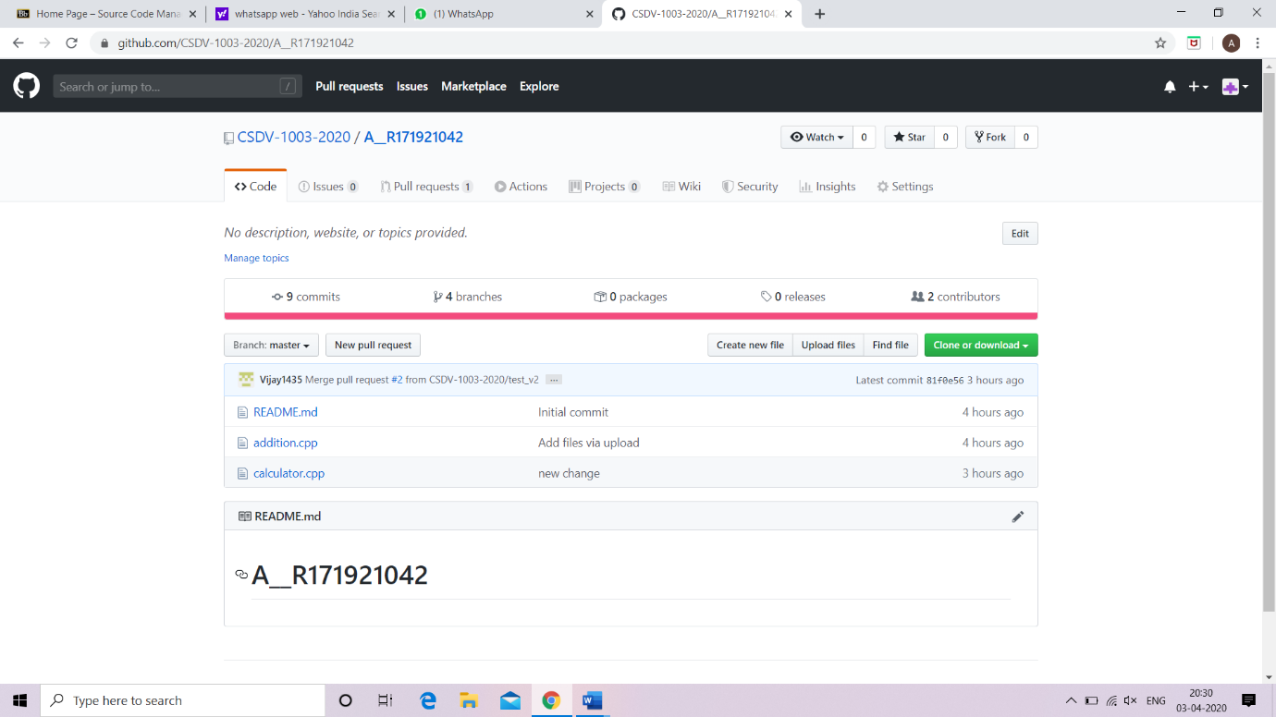
* Check the branch which you want to create pull request with master or some other branch then click  then you are done. Pull request created.

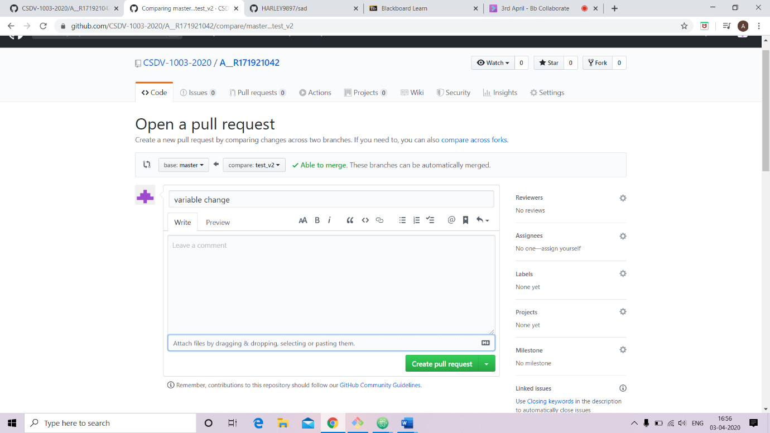

CLOSING A PULL REQUEST

Closing a pull request by merging or simply closed. In merging there are two possibility .

(i) Auto-Merging

(ii) Merging by resolving conflicts

CASE-I: AUTO MERGING

Open you GitHub account and open a repository in which there is pending pull request.

* Click on  it shows the number of pull request pending.
* Click on any pull request that you want to close
* Now you have two option to close the pull request –

(i)-Simply click on close pull request without merging.

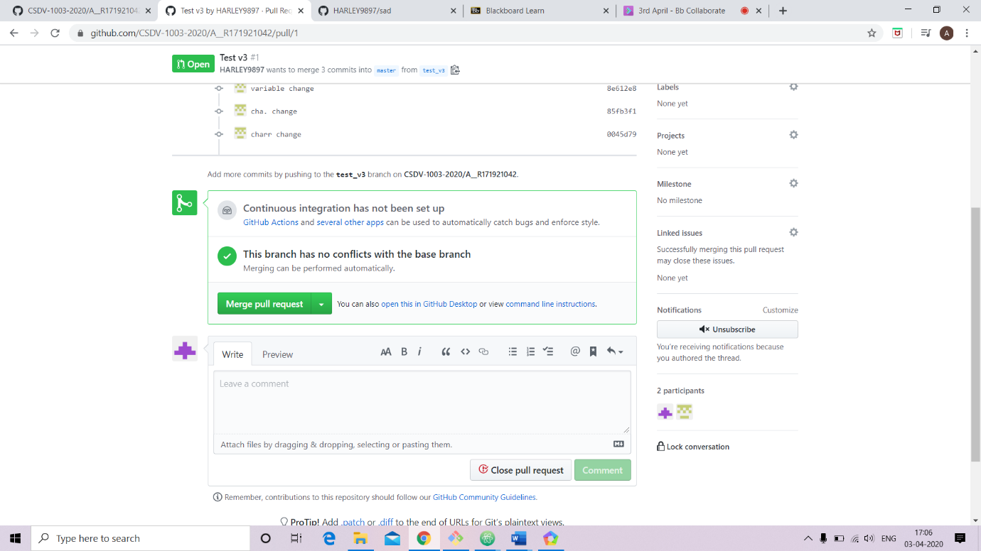

(ii)-Click on Merge pull request it will merge and automatically close the pull request.



CASE- II: MERGING CONFLICT

* Do the first and second step same as in case of auto merging.
* Now you have two option to close the pull request –

(i)- Close the pull request without solving the conflict.

(ii)-Resolve conflict and then merge. Steps are follow🡪

* Click on resolve conflict

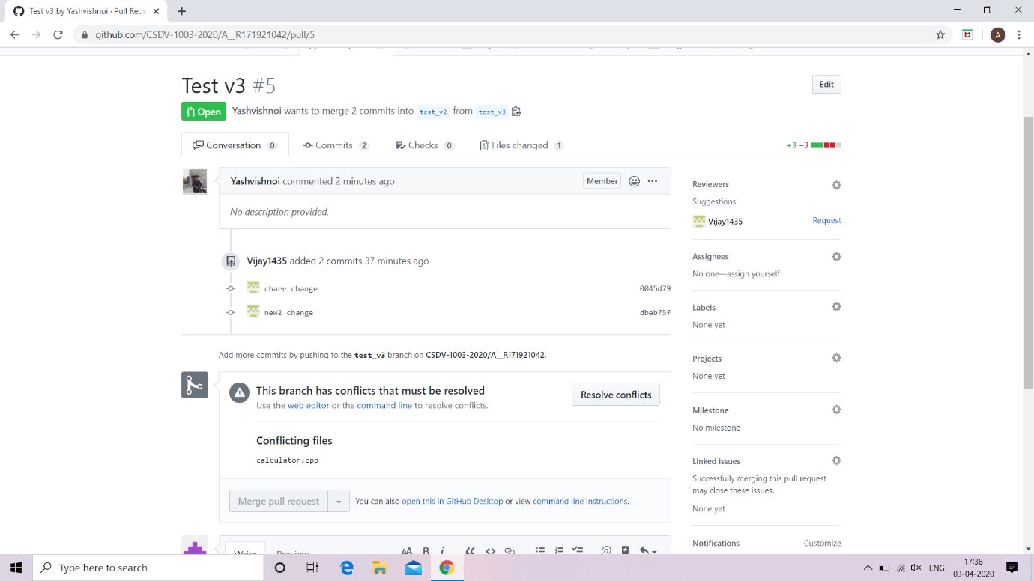

* then a screen appear where conflict is created

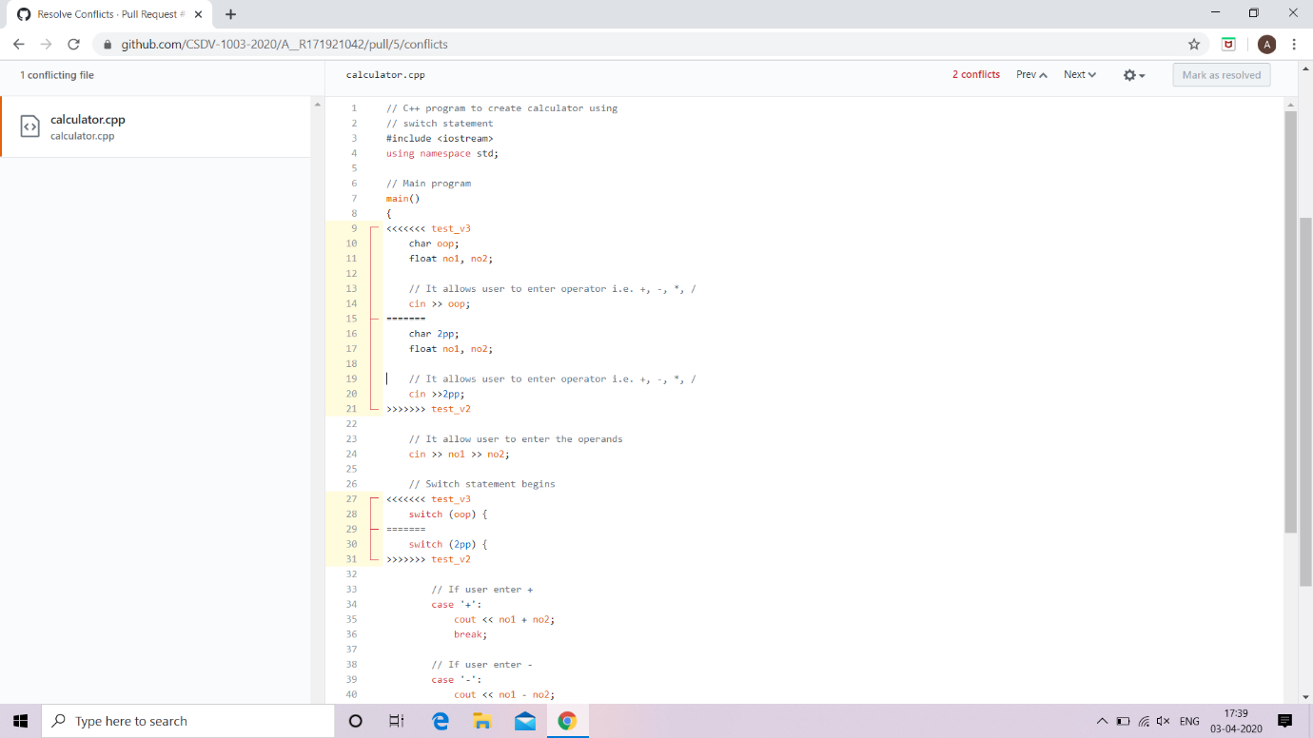

* resolve that conflict then click mark as resolved button

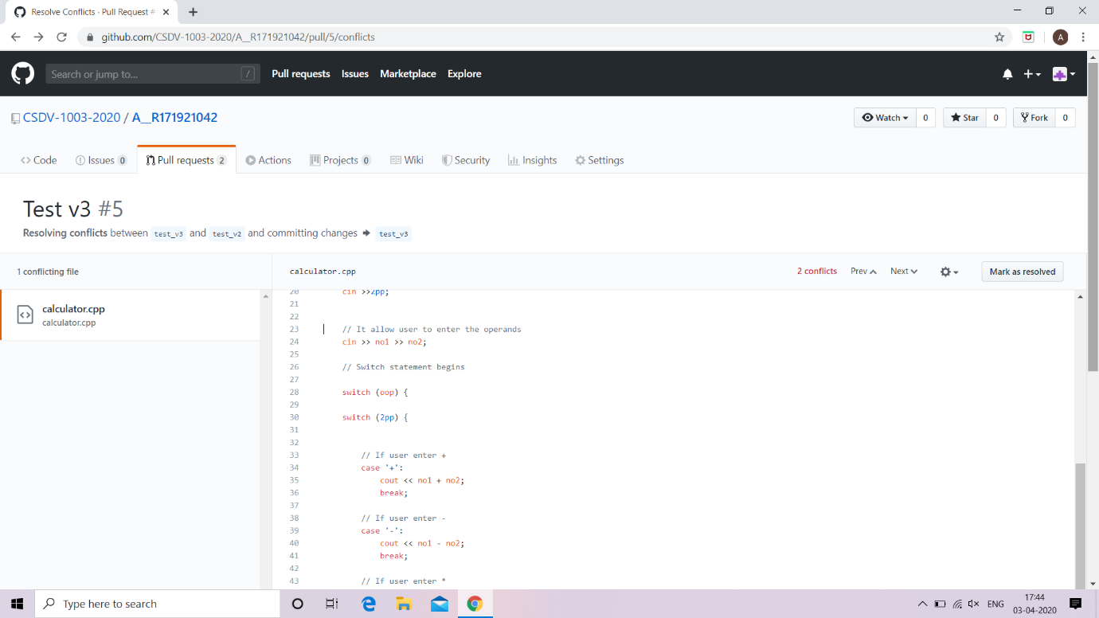

* Then click commit merge

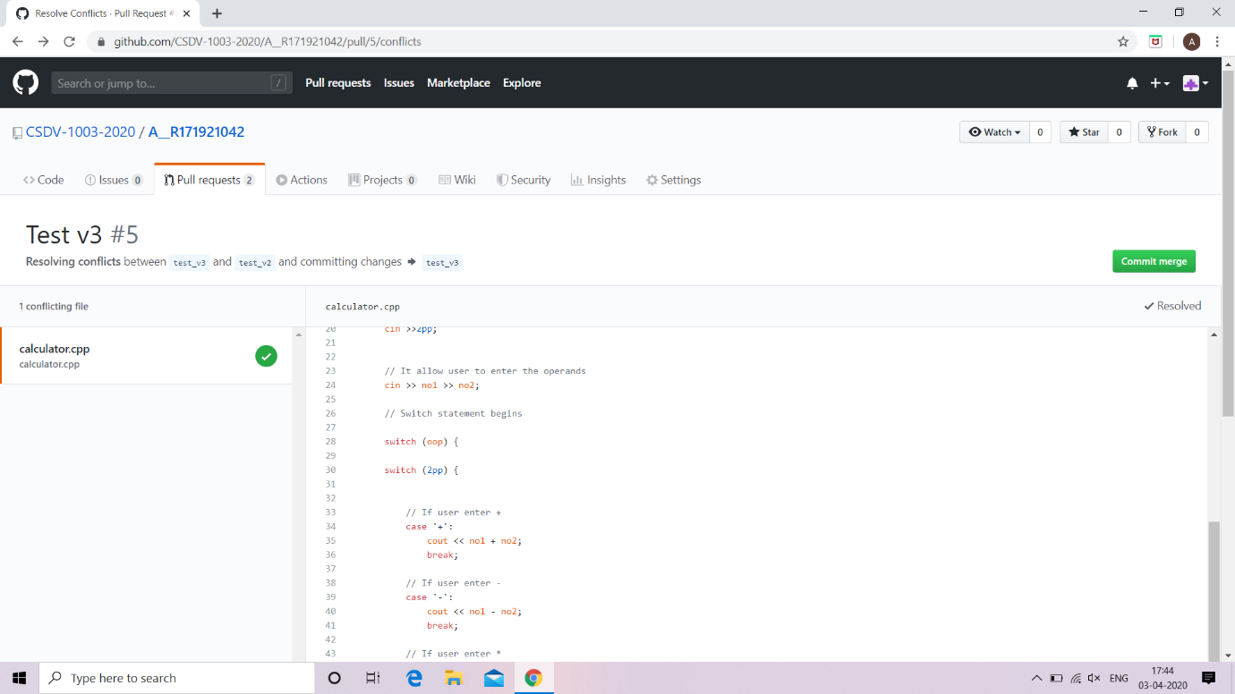

* when you done this then a new screen appear click on merge pull request button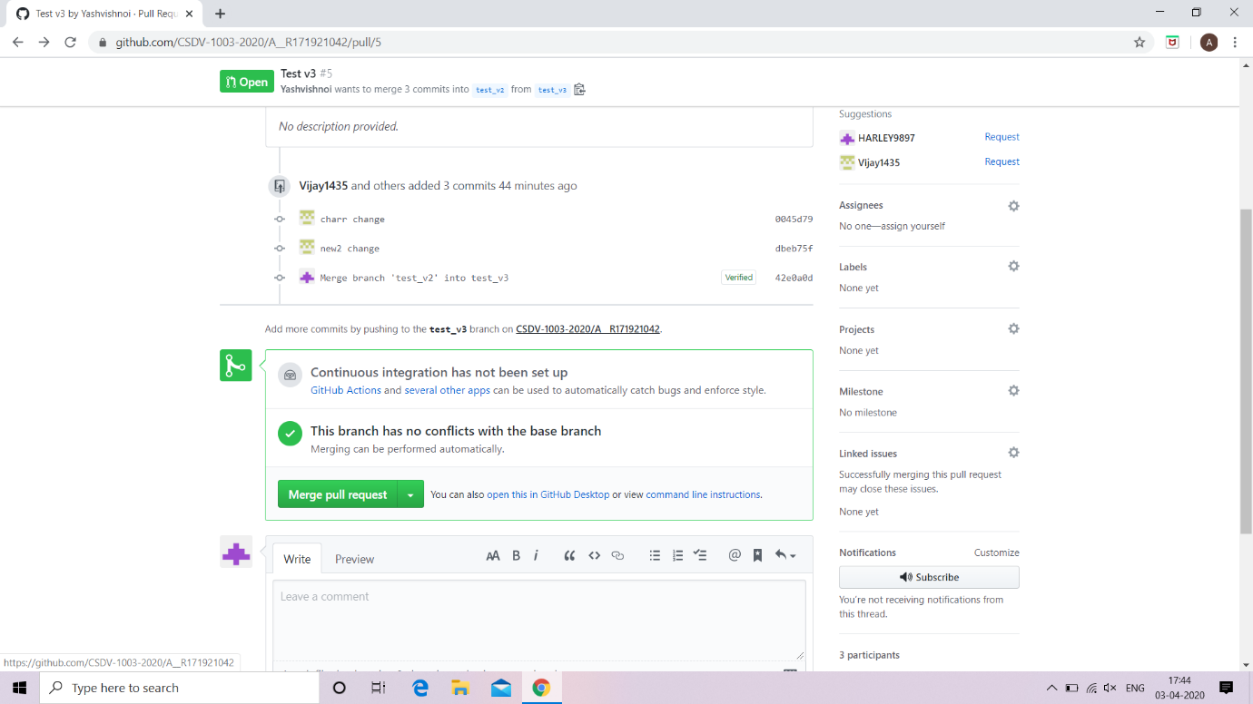
* then you click confirm merge

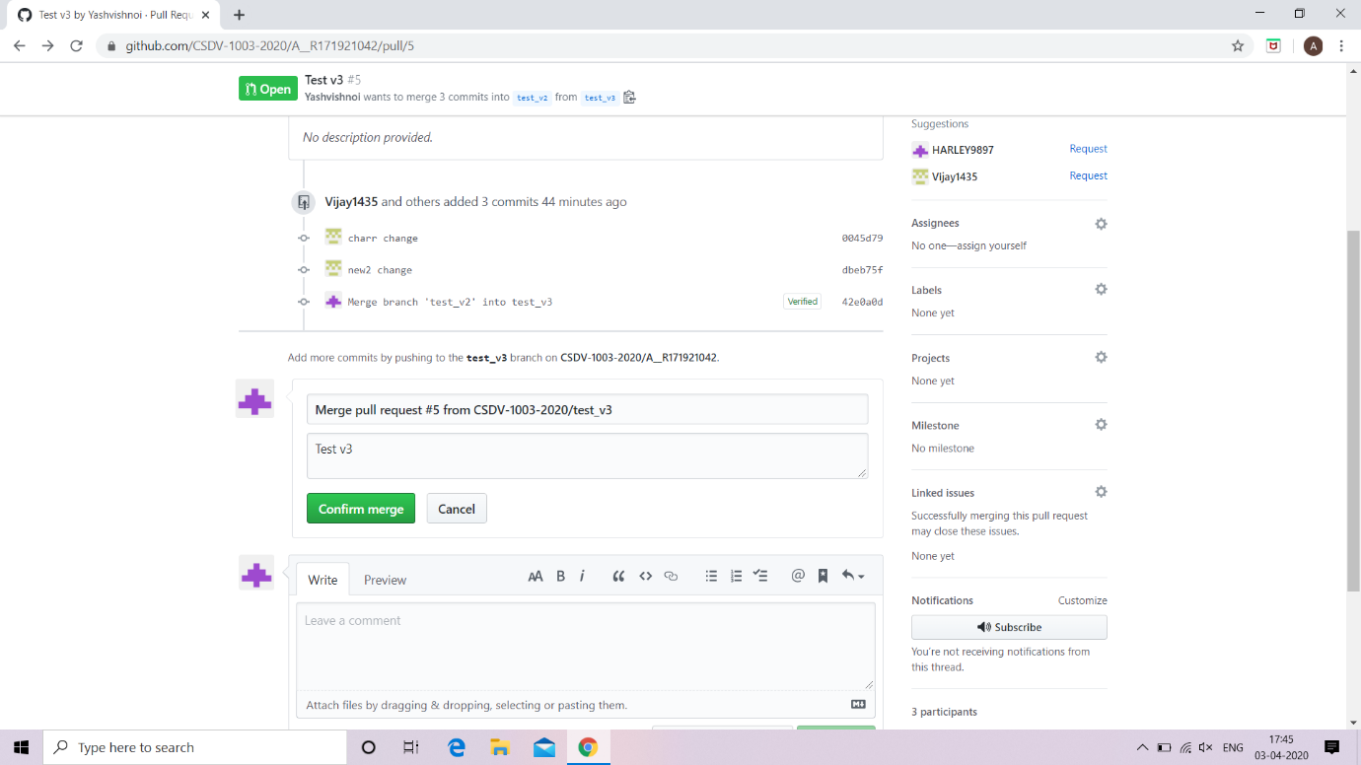

* then your pull request is successfully merged.